LUNA (Library Utility and Navigation Assistant)

Specification Document
Isaac Adjei, Sarah Cole, Kelynn Johnson, Kritika Pant, and Najaat Sampong
Senior Project 1
Fall 2025

Table of Contents
Section Page

1. Purpose 2

2. Overview 2

3. Requirements 2
User Stories 2
Requirements 4
Features 4

4. Traceability Matrix 5

5. Design 5
Applications 5
Front End
Backend
Robot 6

6. Technologies 6

7. Additional Features 7

8. Database Design 8

9. User Interface (Mock-ups) 9

10. Test Strategy and Test Plan 11

11. References 12

Purpose
The purpose of this project is to develop an autonomous library robot capable of picking up, transporting, and delivering books within a library environment. The system aims to reduce librarians' physical workload, streamline book return and delivery processes, and enhance accessibility for students and patrons through safe, efficient, automated navigation.

Overview

Problem Statement: Currently, librarians face significant inefficiencies in large or busy libraries where manual collection and shelving consume valuable time. The current manual workflow causes delays for students requesting books, as they must wait for staff to physically locate and retrieve items. LUNA addresses these specific pain points by automating the "heavy lifting" of transport and retrieval.

The Library Book Transport Robot is an autonomous mobile system designed to improve efficiency and reduce manual workload in school libraries. Librarians spend a significant amount of time collecting returned books, transporting them to sorting areas, and distributing sorted materials throughout the library. These repetitive tasks can slow down operations and limit the time librarians have to assist students or manage collections. This project addresses these challenges by introducing a safe, automated solution for book movement within the library.
The robot supports two primary functions: book return transport and book delivery for student requests. It collects returned books from a designated drop-off station and carries them to the sorting desk, reducing the need for librarians to make multiple trips with heavy loads. Once books are sorted, the robot can transport requested items from the sorting area to the front desk or pickup point, allowing students to receive their materials more quickly.
To operate safely and efficiently, the robot uses obstacle detection, mapping, and path planning to navigate the library without collisions. It automatically monitors its battery status, returns to its charging station when needed, and maintains internal logs for maintenance support.
Users interact with the system through a student-centered app for book requests and a librarian dashboard that provides real-time status updates, task notifications, and system monitoring. The robot also integrates with the library’s existing catalog system to receive book data and maintain accurate transport records.

Requirements

Prioritization

P0 | Automated Book Return & Transport  Focus: Robot collects returned books from the drop-off station and transports them to the sorting area.
P1 | Book Retrieval & Delivery  Focus: Students request books via the app, and the robot locates and delivers them to the front desk.

User Stories and Acceptance Criteria

ID | User Story | Acceptance Criteria (Conditions of Satisfaction)
1.a | As a librarian, I want the robot to collect returned books from the drop-off area and carry them to the sorting desk, so that I don't have to carry heavy stacks manually. | • Robot detects when books are placed in the drop-off area .  • Robot travels safely to the location and collects them using a basket or cart attachment.
1.b | As a librarian, I want the robot to collect returned books automatically from the drop-off station, so that I save time on routine book retrieval tasks. | • Robot detects when books are placed in the drop-off area .  • Robot navigates safely from the docking station to the return area without collisions.
1.c | As a librarian, I want the robot to carry collected books to the sorting area, so that I don't have to transport large quantities of books manually. | • Robot navigates safely through the library using a mapped route .  • Robot avoids collisions with people or furniture .  • Robot delivers books to the sorting area without damage.
1.d | As a librarian, I want the robot to confirm when it has delivered books to the sorting area, so that I know the task was successful. | • Robot sends a light, sound, or message alert upon arrival .  • Robot updates the system log or dashboard upon completion.

Book Delivery for Requests

ID | User Story | Acceptance Criteria (Conditions of Satisfaction)
2.a | As a student, I want to request a specific book using a kiosk or app, so that the robot can bring it to me or the front desk. | • Student can request books via title, author, or call number .  • User receives confirmation that the request was received.
2.b | As a student, I want to submit my book request through the kiosk or app so that the library system can notify the robot to retrieve it. | • System records the request and sends details (book ID and location) to the robot .  • Interface clearly shows request status and pickup location.
2.c | As a library system, I want to automatically send book request data to the robot, so that it knows which book to retrieve. | • Robot receives a book title, ID, and pickup point .  • Robot queues the task without human help .  • Robot logs the task as "in progress".
2.d | As a librarian, I want the robot to take the requested book from the sorting area or the alerted pickup point and deliver it to the front desk, so that I can give it directly to the student. | • Robot navigates safely from the sorting area to the delivery point .  • Robot alerts the librarian upon arrival at the front desk.

Safe Navigation

ID | User Story | Acceptance Criteria (Conditions of Satisfaction)
3.a | As a librarian, I want the robot to move around the library safely, so that it doesn't bump into people or furniture. | • Robot moves safely within the library floor using sensors to detect shelves, people, and obstacles .  • Robot avoids students, furniture, and obstacles during transport.
3.b | As a librarian, I want the robot to detect people, shelves, and obstacles using sensors, so that it can stop or reroute before hitting anything. | • Robot uses LiDAR or ultrasonic sensors .  • Robot detects obstacles within a safe range and adjusts speed accordingly.
3.c | As a technician, I want the robot to store and follow a predefined map of the library, so that it can perform tasks efficiently without manual control. | • Robot uses a saved floor map for navigation .  • Robot recognizes safe and restricted zones .  • Robot recalculates routes dynamically when blocked.
3.d | As a librarian, I want the robot to stop immediately when a collision is detected, so that no damage or injuries occur. | • Robot halts immediately on the sensor trigger .  • Robot displays or signals an alert for review.

Power and Maintenance

ID | User Story | Acceptance Criteria (Conditions of Satisfaction)
4.a | As a technician, I want the robot to monitor its battery and automatically recharge, so that it stays powered and ready for use. | • Robot monitors its own battery level .  • Robot returns to docking station and is ready for the next task.
4.b | As a librarian, I want the robot to notify me when its battery is low, so that I can keep it running throughout the day. | • Low battery warnings appear on a dashboard or LED light .  • Robot completes current tasks before docking.
4.c | As a technician, I want the robot to return to its charging station automatically, so that it can recharge without help. | • Robot detects charge level and docks when needed .  • Robot resumes queued tasks after charging.
4.d | As a technician, I want the robot to track and log its maintenance status, so that I can identify and fix potential issues before they cause downtime. | • Robot monitors key components such as battery health, motor performance, and sensor functionality .  • Maintenance alerts appear on the dashboard when any component shows irregular readings.

Communication and Updates

ID | User Story | Acceptance Criteria (Conditions of Satisfaction)
5.a | As a librarian, I want the robot to send updates and task completion notifications, so that I always know what's happening without checking manually. | • Robot updates a dashboard or sends alerts for each completed trip .  • Logs are stored for tracking performance.
5.b | As a librarian, I want to receive notifications when tasks are completed, so that I can manage library flow efficiently. | • Dashboard updates throughout the task and marks completion accurately .  • Students and librarians receive immediate updates on task status and book readiness.
5.c | As a student, I want an easy-to-use interface to request books from the robot, so that I don't have to understand technical systems. | • Interface has a search bar for title, author, or keyword .  • Interface clearly shows request status and pickup location.
5.d | As a librarian, I want a simple dashboard or app interface to monitor the robot's status and task progress, so that I can coordinate tasks easily and avoid confusion. | • Dashboard lists current, completed, and pending tasks .  • Dashboard has "Pause," "Resume," and "Redirect" controls.
5.e | As a librarian, I want the robot to integrate with the library's catalog or database system, so that transport logs are automatically tied to book IDs, and tasks can be analyzed later. | • System logs book IDs, timestamps, and locations automatically .  • Syncs with the library's existing book catalog to ensure accurate book availability and metadata.

Features
1) Book Transport Function (deliver requested books to desk/student)
2) Student Request Interface Feature (kiosk/app)
3) Safe Navigation & Obstacle Detection Function
4) Mapping & Path Planning Function
5) Battery Monitoring & Auto-Recharge Function
6) Maintenance Logging Feature
7) Notifications & Alerts Function (task completion, status updates)
8) Central Control Function (task coordination & system command management)
9) Library System Integration Function (send book data to robot; catalog sync)
10) Librarian Dashboard Feature

Traceability Matrix (Traceablility Matrix)

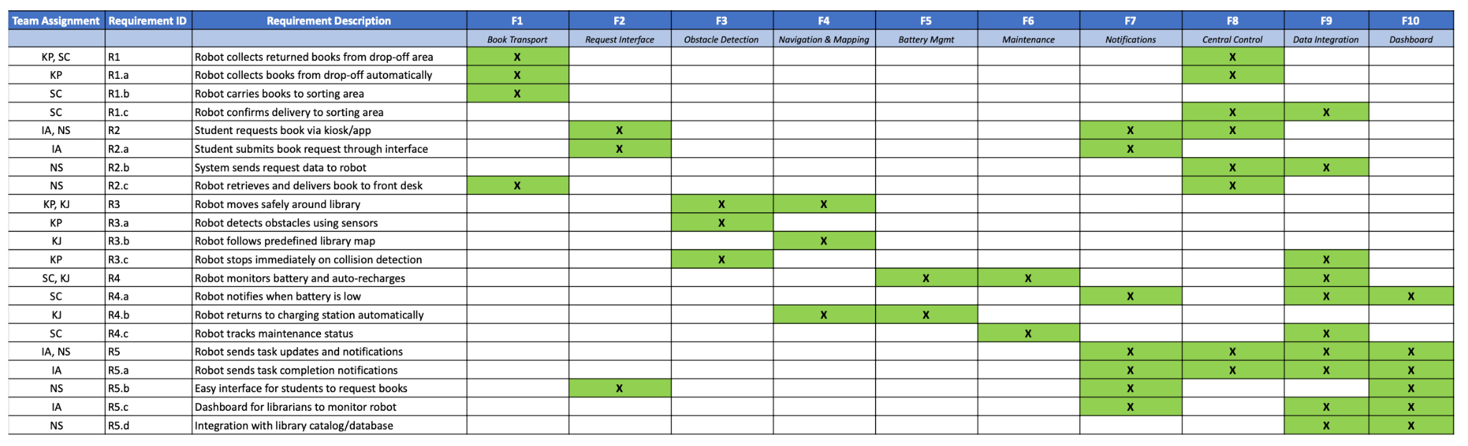
Design

Application
Our project will consist of two main applications and the robot itself, working together to support the library’s workflow. The first application is a student-side mobile app that allows students to search for books, submit requests, and view the status of their pickups. The next is a librarian's side dashboard designed to provide real-time insight into the robot’s activity, including current tasks, battery level, location, and any alerts that require attention. Both applications communicate with a centralized backend system that coordinates tasks and connects to the robot.

Front End
The front end consists of two interfaces tailored to different users. The student application provides a simple, accessible way for students to request books or initiate return actions. Its design focuses on clarity and ease of use, offering basic search functionality and a straightforward request flow. Students can quickly submit a request and receive updates without needing to understand the robot or backend system.
The librarian dashboard is a browser-based interface that emphasizes monitoring and operational control. Through the dashboard, librarians can view the robot’s current status, oversee task queues, and manually intervene when necessary. The dashboard consolidates robot task history and system alerts into a single interface, allowing staff to manage library operations more efficiently. Its purpose is to ensure librarians always know what the robot is doing and can override or adjust tasks if needed.

Backend
The backend serves as the central coordination system for the entire project. It handles communication between the student app, librarian dashboard, and the robot, translating user actions into robot tasks. The backend maintains a task queue, logs robot activity, and manages state transitions as tasks move from creation to completion. It also integrates with the library’s catalog system to retrieve book data and attach relevant information to requests. Through this integration, the backend can associate each task with book metadata and maintain accurate transport records.
In addition to task handling, the backend manages robot communication. It sends navigation routes to the robot, receives status updates, and determines when the robot should return to its dock for charging. By centralizing all task logic and system intelligence, the backend ensures consistent behavior and reliable coordination across the entire system.

Robot
The robot functions as the physical component of the system, carrying out book transport tasks within the library. Built on a TurtleBot platform, it uses sensors such as LiDAR or depth cameras to navigate safely through the environment. The robot relies on mapping and path planning algorithms to move between predefined library locations, including the return station, sorting desk, front desk, bookshelves, and charging dock.
Onboard software handles real-time navigation, obstacle detection, and task execution. When the backend assigns a task, the robot travels to the appropriate location, waits for books to be placed or removed, and then continues to its destination. It reports its progress and status back to the backend, ensuring that the dashboard and student app always reflect up-to-date information. The robot also monitors its own battery level and automatically returns to the charging dock when needed. Overall, it serves as the automated transport mechanism that links the library’s book return, sorting, and delivery processes together.

Realistic Capabilities: Based on the TurtleBot platform, the robot's scope is strictly defined as:

- Book pickup via a drop-off zone (basket/cart attachment).
- Transport to sorting/delivery points.
- Safe navigation with obstacle avoidance.
- Basic signaling via light/sound for status updates.

Note: Advanced features such as robotic arms for shelving are explicitly out of scope for this iteration

Technologies
The following technologies will be used to build the LUNA system and support communication between the robot, backend, and user interfaces:

Programming
- Python – Core language for robot control, sensor processing, and backend logic.
- JavaScript / TypeScript – Used for the web-based librarian dashboard.

Frameworks & Libraries
- ROS2 – Handles navigation, mapping, path planning, and robot behavior.
- React – Used to build the librarian dashboard interface.
- Flask or FastAPI or Java – Backend API for communication between the robot, dashboard, and student request system.
- OpenCV / LiDAR Drivers – Supports obstacle detection and depth sensing.

Hardware
- TurtleBot Platform – Base robot hardware and mobility system.
- LiDAR / Depth Camera – Primary sensors for safe autonomous navigation.
- Ultrasonic Sensors – Secondary obstacle detection for close-range safety.

Database & Infrastructure
- PostgreSQL or MySQL – Stores books, tasks, and system data.
- WebSockets – Enable real-time updates and robot status streaming.

Tools
- GitHub – Source control and team collaboration.
- Docker – Containerized backend services.

Additional Features

Task Scheduling
Allows librarians to queue tasks or prioritize urgent book requests.
Real-Time Notifications
Sends students and librarians immediate updates on task status, book readiness, and robot activity.
Error & Recovery Handling
If the robot encounters a blocked path or minor error, it attempts safe recovery or notifies the dashboard.
Maintenance Logs
Automatically records system health data such as battery cycles, sensor activity, and navigation accuracy.
Catalog Integration
Syncs with the library’s existing book catalog to ensure accurate book availability and metadata.

Database Design

Book Database

id | a unique identifier for each book record, used as the primary key
title | the title of the book as it will appear in searches and on the student interface
author | the main author or authors of the book
isbn | the ISBN, used to identify a specific edition of the book uniquely
location | the current location of the book within the library (shelf code, section, or room)
available | a boolean flag indicating whether the book is currently available for request or is checked out, missing, or in processing
category | a high-level category or classification of the book, such as subject area or genre
description | a short description or summary of the book, used to provide more context in the user interface

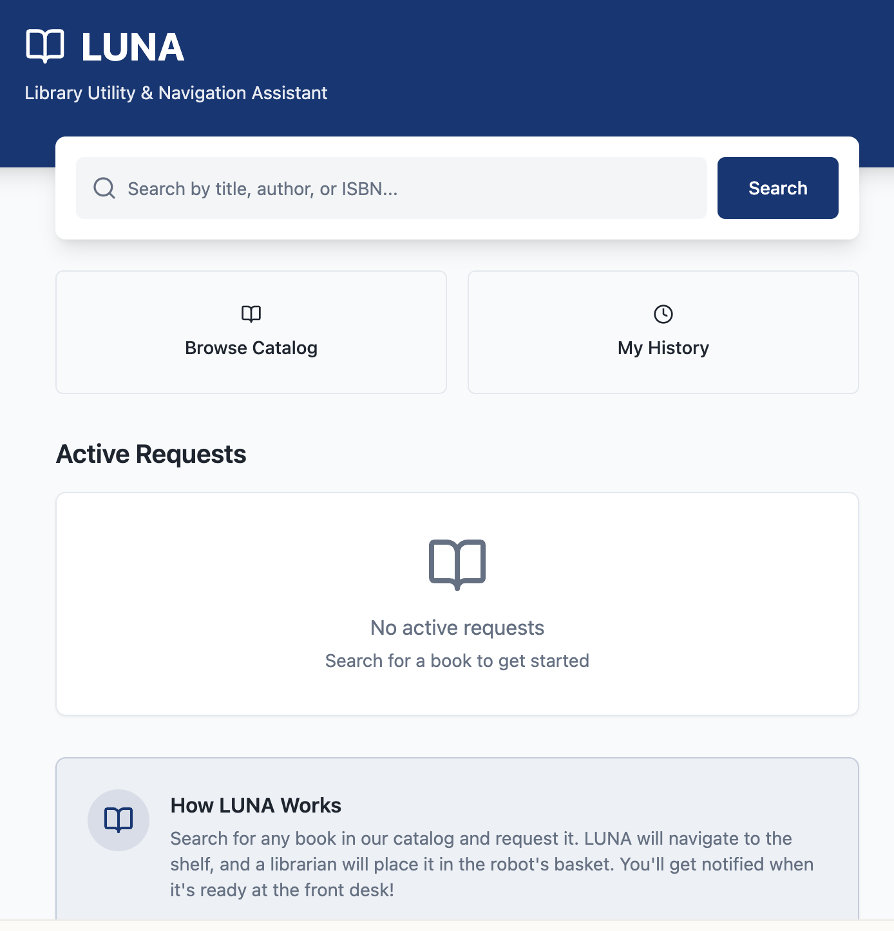
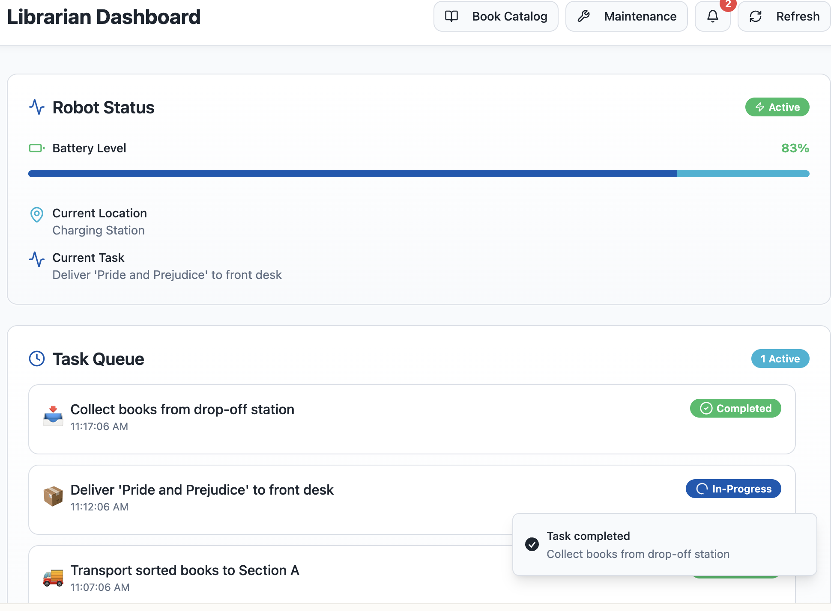
User Interface (Mock Ups)

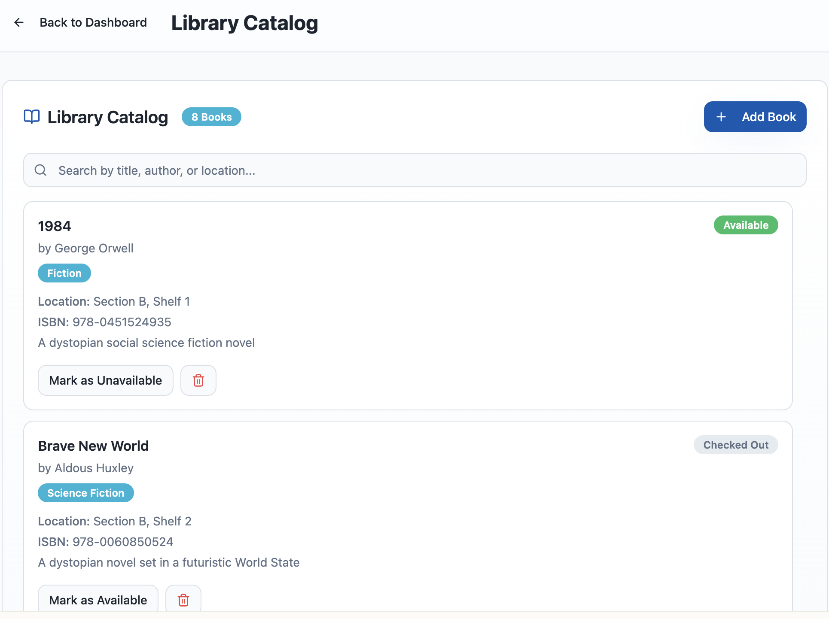
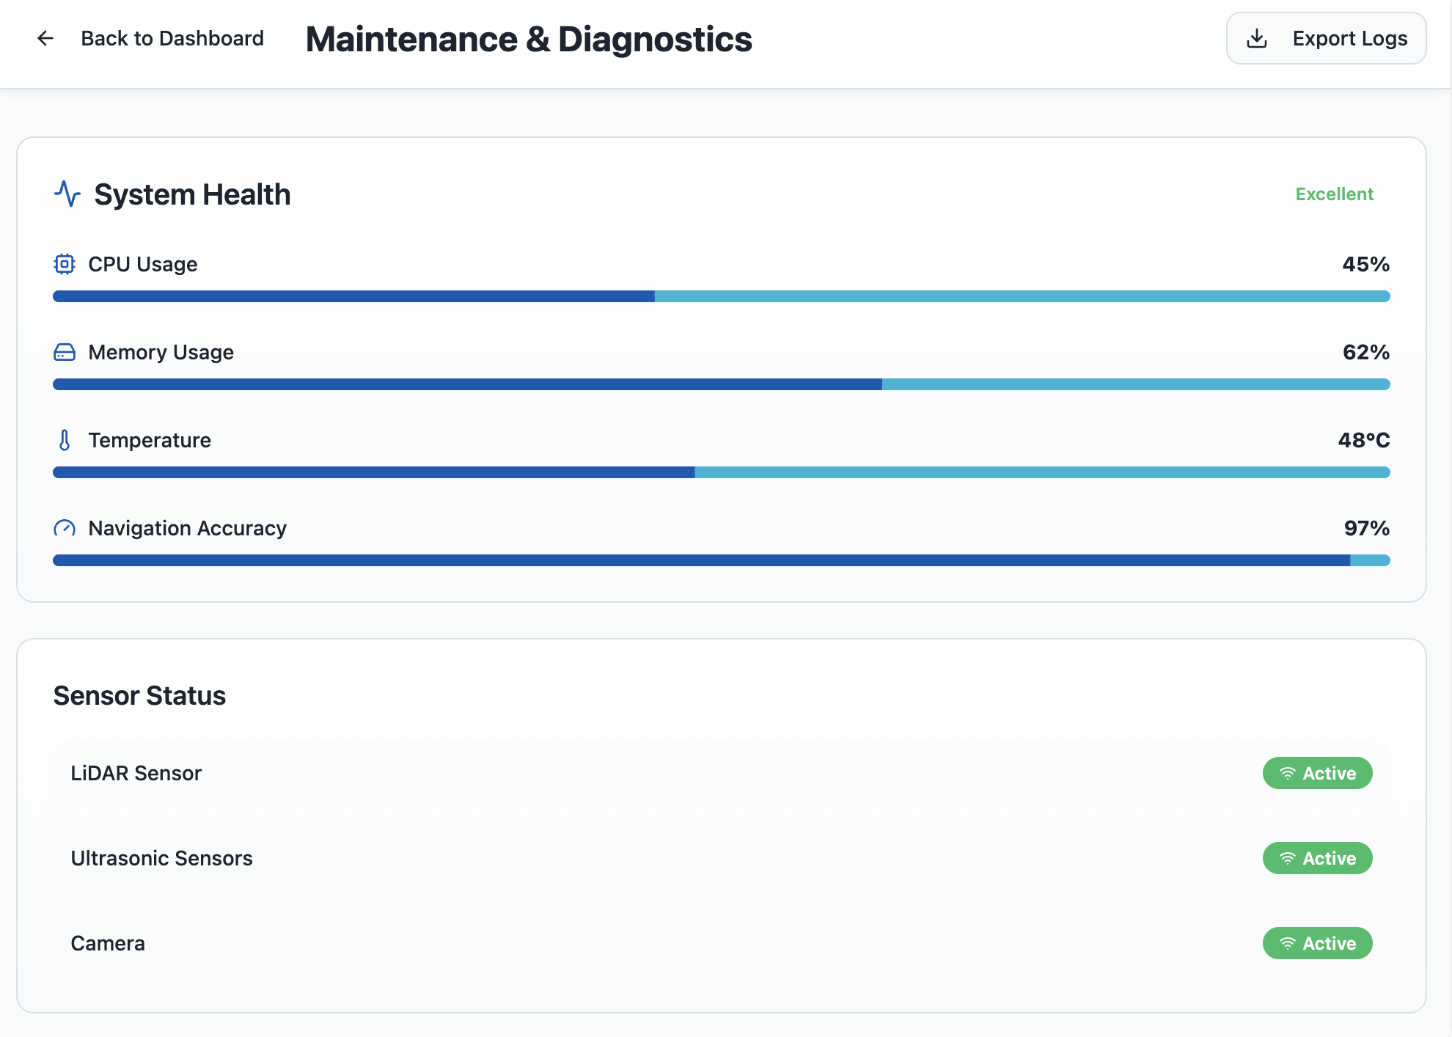

Test Strategy
The test strategy focuses on verifying that all components of the LUNA system, i.e, robot, backend, and user interfaces, operate reliably, safely, and consistently within a real library environment.

Key Testing Areas
- Functionality - Ensure the robot can collect returned books, deliver requested books, and update task statuses accurately.
- Navigation & Safety - Confirm the robot detects obstacles, stops safely, reroutes when necessary, and follows planned paths smoothly.
- Communication - Verify consistent data flow between the robot, backend, student interface, and librarian dashboard.
- Performance - Measure system responsiveness, task completion speed, battery behavior, and stability during continuous operation.
- User Experience - Validate that students and librarians can easily use the interface and understand system updates and alerts.

Test Plan

Book Return Workflow
- The robot receives a return-collection task.
- Navigates to the drop-off area, collects books, and transports them to the sorting desk.
- Dashboard updates throughout the task and marks completion accurately.

Student Request Delivery
- Students submit a book request through the app.
- The robot retrieves the requested book from the sorting area.
- The robot delivers the book to the front desk.
- Request status updates in real time on the interface.

Battery Management
- The robot identifies low battery levels.
- Automatically pauses tasks and returns to the charging dock.
- Dashboard accurately displays battery updates.

Obstacle Handling
- A robot encounters a person or object in its path.
- The robot safely stops, waits, or reroutes without collision.
- The system logs the event if necessary.

System Health Check
- The maintenance dashboard displays correct sensor activity, CPU/memory usage, and temperature.
- Logs export successfully for diagnostics.

References
- ROS2 (Robot Operating System) Documentation – Navigation, mapping, and robot middleware.
- TurtleBot Platform Documentation – Hardware specifications and sensor integration.
- React Documentation – Front-end development for the librarian dashboard.
- Flask / FastAPI Documentation – Backend API development.
- PostgreSQL / MySQL Documentation – Database design and management.
- OpenCV Documentation – Sensor and computer vision support.
- WebSocket Protocol Documentation – Real-time communication standards.
- Project Specification Content (LUNA Specification Document).

